PRACTICAL LIST – AY: 2026- 27
Sr. no. | Title
9. | Title: AI-Assisted Case Generation using ChatGPT  Aim: To generate software test cases using AI and compare them with Test manually created test cases.  Software Required  ● ChatGPT  ● Browser  ● MS Word  Procedure  1. Select software requirement.  2. Generate test cases using ChatGPT.  3. Review generated cases.  4. Classify positive, negative, boundary, and exception cases.  5. Compare with manual test cases.  6. Document findings.  Expected Outcome: AI improves test case coverage and reduces manual  effort.  Result: AI-assisted testing successfully completed.
Solution:
Step 1: Preparing the Inputs
The quality of test cases generated by ChatGPT depends heavily on the input you provide. Your prompts should ideally include:
- Requirement/User Story: Provide detailed context.
- Expected Behavior: Mention acceptance criteria if available.
- Format Requirement: Specify if you want test cases in tabular form, Gherkin syntax, or numbered lists.
- Scope: Mention whether you need functional, negative, boundary, or UI test cases.
Example Input: "Here is a requirement: The login page should allow users to log in using valid credentials. If invalid credentials are entered, an error message should be displayed. Password must be at least 8 characters long. Generate 10 functional and 5 negative test cases in tabular format."

Step 2: Generating Test Cases with ChatGPT
Using the input above, ChatGPT might generate something like these

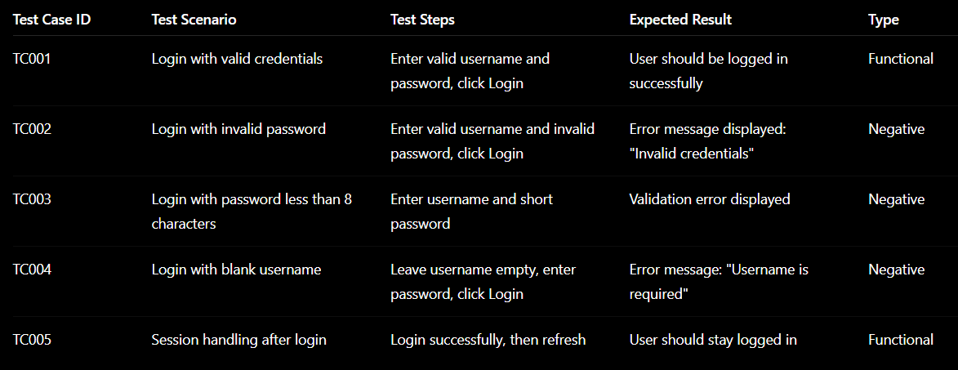

Step 3: Refining the Output
AI-generated test cases should not be taken as-is. Review and refine them to:
- Remove duplicates.
- Add missing edge cases.
- Adapt to your project’s specific standards (naming conventions, severity, test data).
- Confirm alignment with acceptance criteria.
For instance, if your organization requires preconditions in every test case, you can prompt ChatGPT again: "Regenerate the above test cases by including preconditions for each one."

Step 4: Using Different Formats
ChatGPT is flexible and can generate test cases in various formats.
- Tabular Form (good for documentation): ID, Steps, Expected Result.
- Gherkin Syntax (BDD):

Scenario: Login with valid credentials
Given the user is on the login page
When the user enters valid credentials
Then the user should be logged in successfully

Checklist Style (quick smoke testing):
- Login with valid credentials
- Login with invalid password
- Leave username blank and login

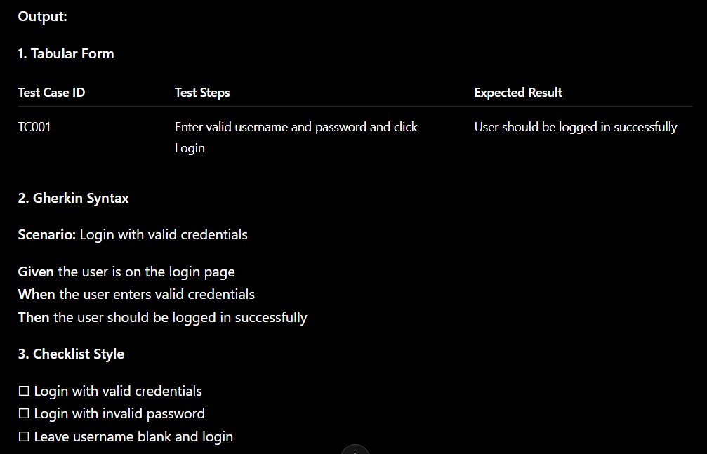
Step 5: Expanding Beyond Functional Test Cases
ChatGPT can also help generate other types of test cases:
UI/UX Test Cases
- "Verify that the login button is aligned correctly on all screen sizes."
- "Check whether the error message text is readable with color contrast."
Security Test Cases
- "Attempt SQL injection in the username field."
- "Check session timeout after inactivity."
Performance Test Scenarios
- "Login with 1000 concurrent users and measure response time."
Boundary Value & Equivalence Partitioning
- Password with 7, 8, and 9 characters to check validation.

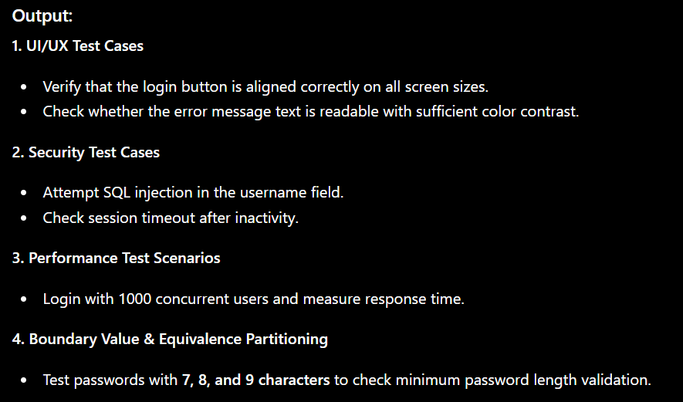

Step 6: Integrating ChatGPT into the Testing Workflow
To maximize efficiency, testers can integrate ChatGPT with their existing workflow:
- Requirement Review: Use ChatGPT during sprint grooming to draft possible test scenarios.
- Test Management Tools: Export AI-generated test cases into tools like JIRA, TestRail, or Zephyr.
- Automation Scripts: Ask ChatGPT to convert test cases into Selenium, Cypress, or Playwright automation code skeletons.
- Collaboration: Share AI-generated test cases with developers and product owners to validate coverage.



